**GAIGHATA GOVERNMENT POLYTECHNIC**

Estd: 2017

MAJOR PROJECT

Project Report On: Bluetooth Control Car Using ESP32

Stream: Electrical Engineering

3rd Year (6th Semester)

Supervised by: Sri Kalyan Sarkar

Project report submitted by:

BIJAY KUNDU D222310389

PRAHLAD DAS D222310367

UTTAM KUMAR PAUL D222310402

RAVI KUMAR MAHATA D222310380

PALASH KARMAKAR D222310360

DIPAN PAUL D222310387

**CERTIFICATE**

This is to certify that BIJAY KUNDU(D222310389)

PRAHLAD DAS (D222310367)

UTTAM KUMAR PAUL (D222310402)

RAVI KUMAR MAHATA (D222310380)

PALASH KARMAKAR (D222310360)

DIPAN PAUL (D222310387)

have successfully completed the project “Bluetooth Control Car Using ESP32” at Gaighata Government Polytechnic under our supervision and guidance in the fulfilment of requirement of 6th semester of Diploma in Electrical Engineering of West Bengal State Council of Technical & Vocational Education and Development, Kolkata.

__________________________________

Lecturer (Project Guide) Kalyan Sarkar

Electrical Engineering,

Gaighata Government Polytechnic

__________________________________

Lecturer **Subhajit Paramanik**

Head of the Department Electrical Engineering,

Gaighata Government Polytechnic

**ACKNOWLEDGEMENT**

We have taken efforts in this project. However, it would

not have been possible without the kind support and help of

many individuals. I would like to extend my sincere thanks to all

of them. It has been great honour and priviledge to undergo

training at Gaighata Government Polytechnic.

We are highly indebted to Sri Kalyan Sarkar for

their guidance and constant supervision as well as for providing

necessary information regarding the project and also for his

support in completing the project. His constant guidance and

willingness to share his vast acknowledge made us understand

this project and its manifestations in great depths and helped us

to complete the assigned tasks on time. I would like to express

my gratitude towards my team member for their kind

cooperation and encouragement which help me in completion

of this project.

At last, we wish to express gratitude towards our all

teachers, who helped us throughout our courses work. We

extend our acknowledgment to our lab mates, lab staff, who are

directly or indirectly involved in carrying our project work.

|  |  |  |
| --- | --- | --- |
| SL. NO. | CONTENTS | PAGE NO |
| 1 | INTRODUCTION | 5 |
| 2 | EXPLANATION | 6 |
| 3 | COMPONENTS REQUIRED | 7-16 |
| 4 | CIRCUIT DIAGRAM | 17 |
| 5 | ARDUINO PROGRAM | 18-19 |
| 6 | APPLICATION CONTROL | 20 |
| 6 | OUT COME | 21 |
| 7 | CONCLUSION | 22 |

**INTRODUCTION**

The integration of wireless communication technologies with embedded systems has opened new frontiers in automation and remote control applications. This project, titled **"Bluetooth Controlled Car Using ESP32,"** demonstrates the use of the ESP32 microcontroller to design and develop a smart car that can be controlled wirelessly via Bluetooth. The ESP32, with its built-in Bluetooth and Wi-Fi capabilities, serves as the central processing unit, receiving commands from a smartphone and translating them into movement instructions for the car. This project not only showcases practical implementation of Bluetooth communication but also highlights the growing relevance of IoT (Internet of Things) in everyday automation tasks. By enabling real-time, wireless control of the vehicle, the system offers a simple yet powerful demonstration of how embedded systems can be leveraged for smart mobility solutions.

**EXPLANATION**

A **Bluetooth Controlled Car Using ESP32** operates by receiving wireless commands from a smartphone or Bluetooth-enabled device and translating those commands into motion through motor drivers. The system mainly consists of the ESP32 microcontroller, a motor driver (like L298N), DC motors, and a power source.

**1. Bluetooth Communication**

The ESP32 has built-in Bluetooth capabilities, which allow it to pair with a smartphone. An app (such as a custom app or generic Bluetooth controller app) on the smartphone sends directional commands like **forward**, **backward**, **left**, **right**, or **stop** in the form of characters (e.g., 'F', 'B', 'L', 'R', 'S') via Bluetooth.

**2. Receiving Commands**

The ESP32 listens for incoming Bluetooth signals. When it receives a command, it processes the input using the code uploaded to it via the Arduino IDE or similar platform.

**3. Controlling the Motors**

The ESP32 is connected to a **motor driver module** (such as L298N or L293D), which controls the two DC motors of the car. Based on the received command, the ESP32 sends high or low signals to the motor driver’s input pins, making the motors rotate in the desired direction.

* **Forward:** Both motors rotate forward.
* **Backward:** Both motors rotate in reverse.
* **Left Turn:** One motor stops or rotates slower, and the other rotates forward.
* **Right Turn:** Opposite motor stops or slows down.
* **Stop:** Both motors stop.

**4. Power Supply**

The car is powered by a battery pack (typically 7.4V or 12V), which supplies power to both the motor driver and the ESP32 (sometimes with a voltage regulator if needed).

**5. Real-Time Control**

As long as the smartphone stays within Bluetooth range, the user can continuously send commands to control the car in real time.

**COMPONENTS REQUIRED**

|  |  |  |  |
| --- | --- | --- | --- |
| **SL. NO** | **COMPONENTS** | **RATINGS/PICES** | **PRICE IN RS** |
| 1. | ESP 32 | 1 PCS | 250 |
| 2. | Driver shield L298N | 1 PCS | 90 |
| 3. | BO MOTOR | 4 PCS | 120 |
| 4. | 3.7 VOLT RECHARGEABLE BATTRY | 3 PCS | 120 |
| 5. | WHEELS |  | 80 |
| 6. | JUMPER WIRE | M2M 10 PCS  F2F 10 PCS  M2F 10 PCS | 60 |
| 7. | ON OFF SWITCH | 1 PCS | 10 |
| 8. | BATTERY CASE FOR 3 BATTERY | 1 PCS | 30 |
| 9. | MISSSLLENOUS COMPONENTS | 1 PCS | 100 |

**THE TOTAL COST IS ₹860 RUPEES**

**ESP 32**

## **ESP32 (38 Pin) WiFi + Bluetooth NodeMCU-32 Development Board**

The ESP32 development board promises to revolutionize the Internet of Things (IoT), creating a powerful and reliable platform for low-cost, highly integrated applications. Featuring an open-source operating system, built-in Wi-Fi, and Bluetooth support, along with two high-speed processors - one dedicated to communication tasks such as packet processing while another handles application code execution. It also supports various industry standard formats including the JTAG debug interface so you can optimize your coding designs without worrying about compatibility issues. Additionally, it comes preloaded with advanced features like PWM outputs & multiple ADCs which makes this perfect for any IoT project that looks at making life easier by automating device operations through remote control services from anywhere in the world within seconds .

Key Features:

* Delivering exceptional performance at an affordable price point.
* It's packed with advanced features and supports LWIP protocol and FreeRTOS.
* With a small volume, it seamlessly integrates into various products.
* Facilitates easy development through Lua programming.
* Supports three modes - Access Point (AP), Station (STA), and AP+STA.

Pin Diagram of Node MCU 38 Pins:

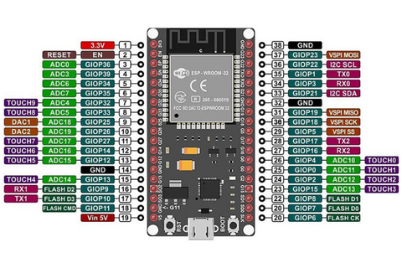

ESP32 to 8266 Comparison:

* ESP32 is a powerful device that runs through a 32-bit dual-core processor CPU with a clock speed of 160MHz to 240MHz while ESP8266 is a single-core CPU with a clock speed of around 80MHz.
* As we know the ESP32 has a higher speed compared to ESP8266 it consumes more power.
* ESP32 has more than 16 GPIO pins along with UART, I2C, I2S, ADC, DAC, and TWAI pins. ESP8266 also comes with 16 General Purpose Input Output (GPIO) Pins and other GPIO, UART, I2C, I2S and ADC Pins.
* ESP32 comes with Bluetooth and WIFI together onboard whereas the ESP8266 comes with only WIFI.

ESP8266 vs. ESP32

|  |  |  |
| --- | --- | --- |
| **Features** | **ESP8266** | **ESP32** |
| Microcontroller | Xtensa Single-core 32-bit L106 | Xtensa Dual-Core 32-bit LX6 with 600 DMIPS |
| Frequency (MHz) | 80 | 160 to 240 |
| Bluetooth | No | Bluetooth 4.2 and BLE |
| SRAM | No | Yes |
| GPIO Pins | 17 (11 Usable Pins) | 38 (32 Usable Pins) |
| PWM | 8 Channels | 16 Channels |
| ADC | 10-bit | 12-bit |
| TWAI | No | Yes |
| Power Consumption | Approx. 70.5 mA | Approx. 80~90mA |
| Working Temperature | -40ºC to 125ºC | -40ºC to 125ºC |
| Price | Comparatively lesser than ESP32 | Comparatively higher than ESP8266 |

Applications:

* Universal low-power IoT sensor hub
* Home automation.
* Mesh network.
* Industrial wireless control.
* Sensor networks.
* Smart Socket.

## **2A Dual L298N Motor Driver Module with PWM Control**

The L298N Motor Driver Module is a great choice for controlling motors! It contains a double H bridge L298N chip, which has a maximum voltage of 46V and a current of 2A. This L298N High-voltage Dual-channel motor driver works with a logic voltage of 5V and can drive motors with a voltage range of 5-35V, giving you good efficiency with a maximum power output of 25W.

One cool feature of the L298N-based motor driver module is that it has current sensing for each motor, so you can easily check how they’re doing. It also features a heatsink to keep it cool while running, which increases efficiency. Also, there is a power-on LED indicator that indicates when it is active. The L298N Module is perfect for controlling DC and Stepper motors, switches, relays, robotic cars, arms, etc.

## **Features:**

* Uses an L298N IC for effective motor control.
* Includes a 78M05 Voltage Regulator for internal circuitry power.
* Jumper enables the voltage regulator for power supplies ≤ 12V; requires separate 5V for supplies > 12V.
* ENA and ENB pins control motor speed; IN1 & IN2 and IN3 & IN4 control motor direction.
* Features a Power LED for status monitoring.
* Compact design with integrated resistors and capacitors for stability.
* Easy to use with popular microcontrollers like Arduino.

## **Pinout**

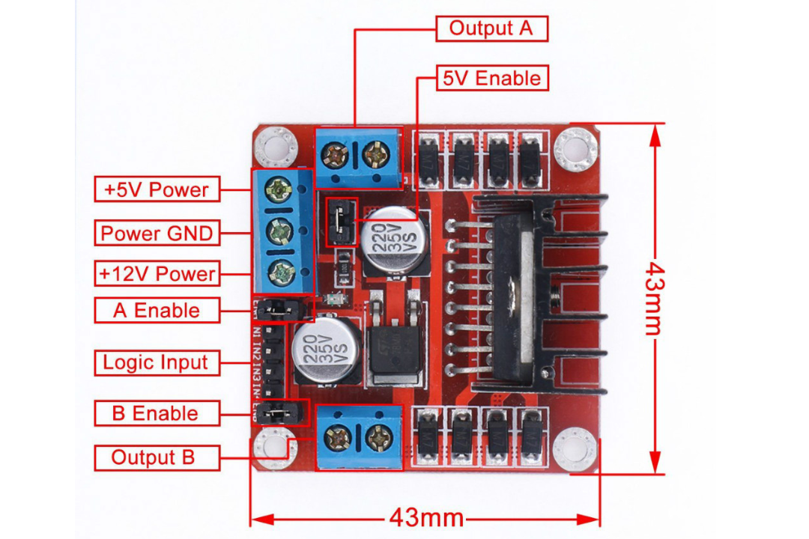

## **Applications:**

* Robotic Cars
* Robotic Arms
* Controlling the motor's speed and direction

## **Specifications:**

|  |  |
| --- | --- |
| Specification | Details |
| Driver Model | L298N 2A |
| Driver Chip | Double H Bridge L298N |
| Motor Supply Voltage (Maximum) | 46V |
| Motor Supply Current (Maximum) | 2A |
| Logic Voltage | 5V |
| Driver Voltage | 5-35V |
| Driver Current | 2A |
| Logical Current | 0-36mA |
| Maximum Power (W) | 25W |
| Current Sense for Each Motor | Yes |
| Heatsink | Yes |
| Power-On LED Indicator | Yes |
| Weight (gm) | 25 |
| Dimensions (mm) | 44 x 44 x 28 (L x B x H) |

**BO Motor**

The drive shaft has a clutch for noncontinuous protection from overload which protects gears from sudden overload. This straight BO motor runs smoothly from 2V to 12V and gives a wide range of RPM, and torque. The table below gives a fairly good idea of the motor’s performance in terms of RPM, no load current as a function of voltage, and stall torque, stall current as a function of voltage.

**Features:**

* Cost-effectiveness of the injection-molding process
* Elimination of machining operations
* Low density: lightweight, low inertia Uniformity of parts
* Capability to absorb shock and vibration as a result of elastic compliance
* Ability to operate with minimum or no lubrication, due to inherent lubricity
* Relatively low coefficient of friction.
* Corrosion-resistance; elimination of plating, or protective coatings
* Quietness of operation
* Tolerances are often less critical than for metal gears, due in part to their greater resilience
* Consistency with the trend to greater use of plastic housings and other components

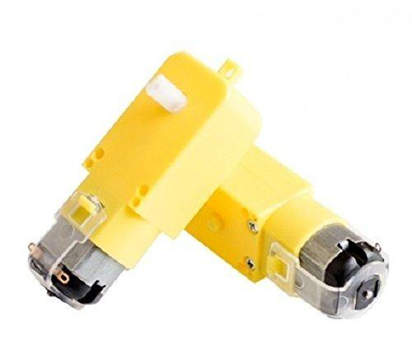

## **3.7v 2000mah 18650 Li-Ion Battery**

18650 battery is a Li-ion rechargeable battery with a 2000 mAh Battery Capacity. This is not a standard AA or AAA battery but is very useful for applications that require continuous high current or high current in short bursts like in cameras, DVD players, iPod, etc. They are safe to use, environment friendly and have long battery life. This [li ion battery](https://robocraze.com/collections/li-ion-batteries) comes with high energy density and provides excellent continuous power sources to your device. It should be used with a protection circuit board that guards the battery against over-charge, over-discharge of the pack, and avoid over-current drawn.

It is very easy to use the cell in any circuit just solder the wires on the terminals or use 18650 battery holders to easily replace the used cells. Care must be taken while handling Li-ion batteries as they are volatile and inflammable and should not be handled roughly and punctured. Also, don’t overcharge and discharge beyond a certain point as gases accumulated inside might result in explosions and fire. So always use the Protection board while using Li-Ion cells

**Features:**

* Safe to use, environment-friendly, and with long battery life
* High energy density for excellent continuous power sources
* Use with a protection circuit board to guard against over-charge, over-discharge, and over-current
* Easy to use in any circuit by soldering wires on the terminals or using 18650 battery holders

**Applications:**

* Cordless Phones
* Tablet PC GPS
* iPod, DVD, MP4 Player, etc.
* Mobiles backup power supply/Power bank

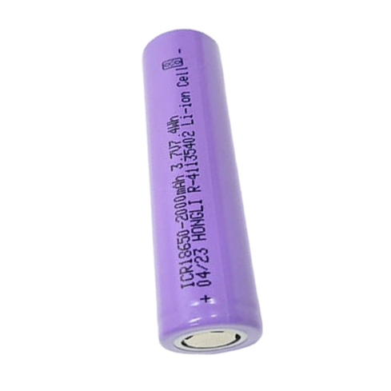

**WHEELS**

These are the BO motor wheels (4 pcs), The wheels are made up of high-quality rubber which gives maximum traction while operating. The wheels are strong and sturdy as they feature a nylon-reinforced plastic rim.

These BO wheels for DIY robot cars are commonly used components in Robotics. With an approximate diameter of 65mm and 26mm thickness, These wheels are suitable for all [BO motors](https://robocraze.com/collections/bo-motors). Can be used in our Robot vehicles with the standard motor/gearbox fitting.

**ON OFF SWITCH**

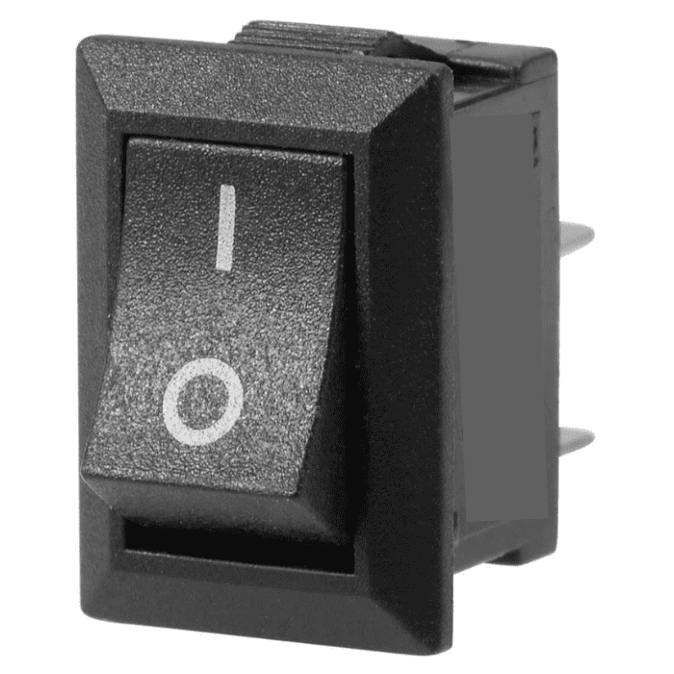

**JUMPER WIRE**

**Jumper Wire Set - M2M, M2F, F2F**

Ribbon Jumper Wires (Pack of 120) is a premium quality Connectors & Jumpers. Robocraze is a well-known eCommerce platform for a qualitative range of Connectors & Jumpers. All Ribbon Jumper Wires (Pack of 120) are manufactured by using quality assured material and advanced techniques, which make them up to the standard in this highly challenging field.

The cables can be separated into single roots as you request to do multiple connections. Widely used in electronic projects for connections. It can be used for the expansion of the experimental board pin and to increase experimental projects. You can quickly conduct circuit testing without welding. It can be reused if the terminal is not damaged.

The materials utilized to manufacture Ribbon Jumper Wires are sourced from the most reliable and official Connectors & Jumpers vendors, chosen after performing detailed market surveys. We are Dedicatedly involved in providing an excellent quality array of Jumpers Wires.

**Applications:**

* Making Temporary Connections using [Breadboard](https://robocraze.com/collections/breadboards)
* Used to create junction between Microcontroller and Sensors using breadboard externally.
* Electronic Experiment Prototyping
* Connecting with Berg Strip Headers

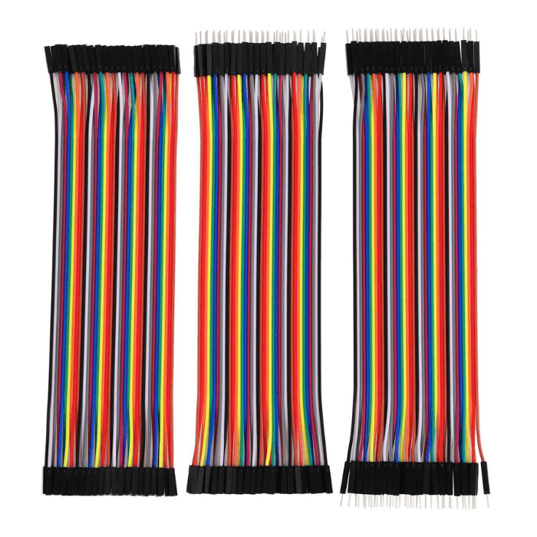

**BATTERY CASE FOR 3 BATTERY**

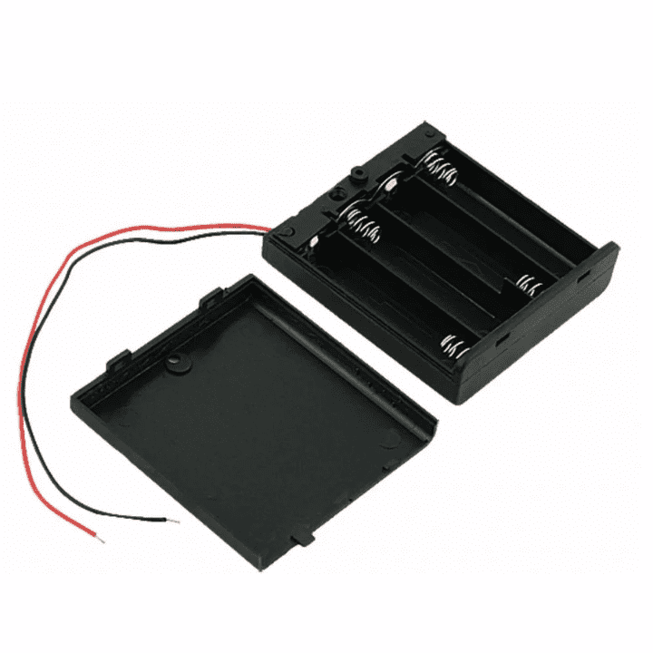

**BATTERY CHARGER**

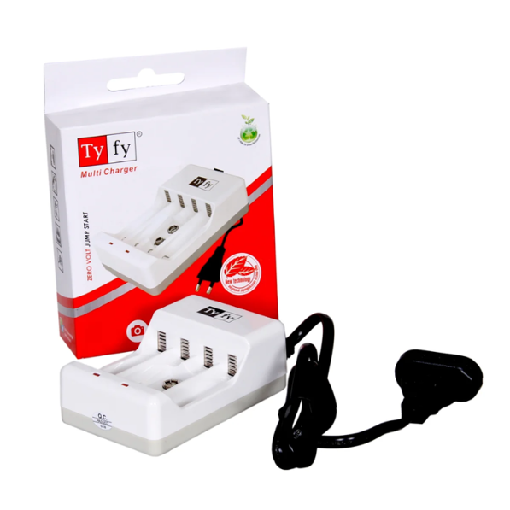

**CIRCUIT DIAGRAM**

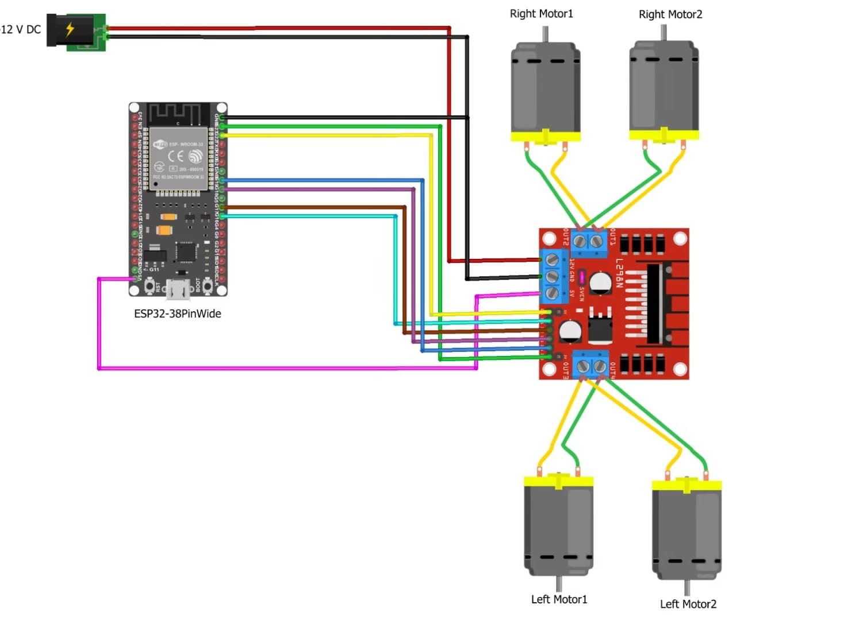

**ESP-32 PROGRAM**

#define CUSTOM_SETTINGS

#define INCLUDE_GAMEPAD_MODULE

#include <DabbleESP32.h>

//Right motor

int enableRightMotor=22;

int rightMotorPin1=16;

int rightMotorPin2=17;

//Left motor

int enableLeftMotor=23;

int leftMotorPin1=18;

int leftMotorPin2=19;

#define MAX_MOTOR_SPEED 255

const int PWMFreq = 1000; /* 1 KHz */

const int PWMResolution = 8;

const int rightMotorPWMSpeedChannel = 4;

const int leftMotorPWMSpeedChannel = 5;

void rotateMotor(int rightMotorSpeed, int leftMotorSpeed)

{

if (rightMotorSpeed < 0)

{

digitalWrite(rightMotorPin1,LOW);

digitalWrite(rightMotorPin2,HIGH);

}

else if (rightMotorSpeed > 0)

{

digitalWrite(rightMotorPin1,HIGH);

digitalWrite(rightMotorPin2,LOW);

}

else

{

digitalWrite(rightMotorPin1,LOW);

digitalWrite(rightMotorPin2,LOW);

}

if (leftMotorSpeed < 0)

{

digitalWrite(leftMotorPin1,LOW);

digitalWrite(leftMotorPin2,HIGH);

}

else if (leftMotorSpeed > 0)

{

digitalWrite(leftMotorPin1,HIGH);

digitalWrite(leftMotorPin2,LOW);

}

else

{

digitalWrite(leftMotorPin1,LOW);

digitalWrite(leftMotorPin2,LOW);

}

ledcWrite(rightMotorPWMSpeedChannel, abs(rightMotorSpeed));

ledcWrite(leftMotorPWMSpeedChannel, abs(leftMotorSpeed));

}

void setUpPinModes()

{

pinMode(enableRightMotor,OUTPUT);

pinMode(rightMotorPin1,OUTPUT);

pinMode(rightMotorPin2,OUTPUT);

pinMode(enableLeftMotor,OUTPUT);

pinMode(leftMotorPin1,OUTPUT);

pinMode(leftMotorPin2,OUTPUT);

//Set up PWM for speed

ledcSetup(rightMotorPWMSpeedChannel, PWMFreq, PWMResolution);

ledcSetup(leftMotorPWMSpeedChannel, PWMFreq, PWMResolution);

ledcAttachPin(enableRightMotor, rightMotorPWMSpeedChannel);

ledcAttachPin(enableLeftMotor, leftMotorPWMSpeedChannel);

rotateMotor(0,0);

}

void setup()

{

setUpPinModes();

Dabble.begin("MyBluetoothCar");

}

void loop()

{

int rightMotorSpeed=0;

int leftMotorSpeed=0;

Dabble.processInput();

if (GamePad.isUpPressed())

{

rightMotorSpeed = MAX_MOTOR_SPEED;

leftMotorSpeed = MAX_MOTOR_SPEED;

}

if (GamePad.isDownPressed())

{

rightMotorSpeed = -MAX_MOTOR_SPEED;

leftMotorSpeed = -MAX_MOTOR_SPEED;

}

if (GamePad.isLeftPressed())

{

rightMotorSpeed = MAX_MOTOR_SPEED;

leftMotorSpeed = -MAX_MOTOR_SPEED;

}

if (GamePad.isRightPressed())

{

rightMotorSpeed = -MAX_MOTOR_SPEED;

leftMotorSpeed = MAX_MOTOR_SPEED;

}

rotateMotor(rightMotorSpeed, leftMotorSpeed);

}

**Application Control**

1.The application name is ‘Arduino ESP Bluetooth -Dabble’ it is available on Play Store and App Store you have to Install the application and open it give the permissions.

2. you have to select the “gamepad” Module.

3.Then you have to go to the top right corner & tap on the connection button then then you have to tap on the “My Bluetooth Car” and you will be connected to the car tap on the Arrows to control the car.

**OUT COME**

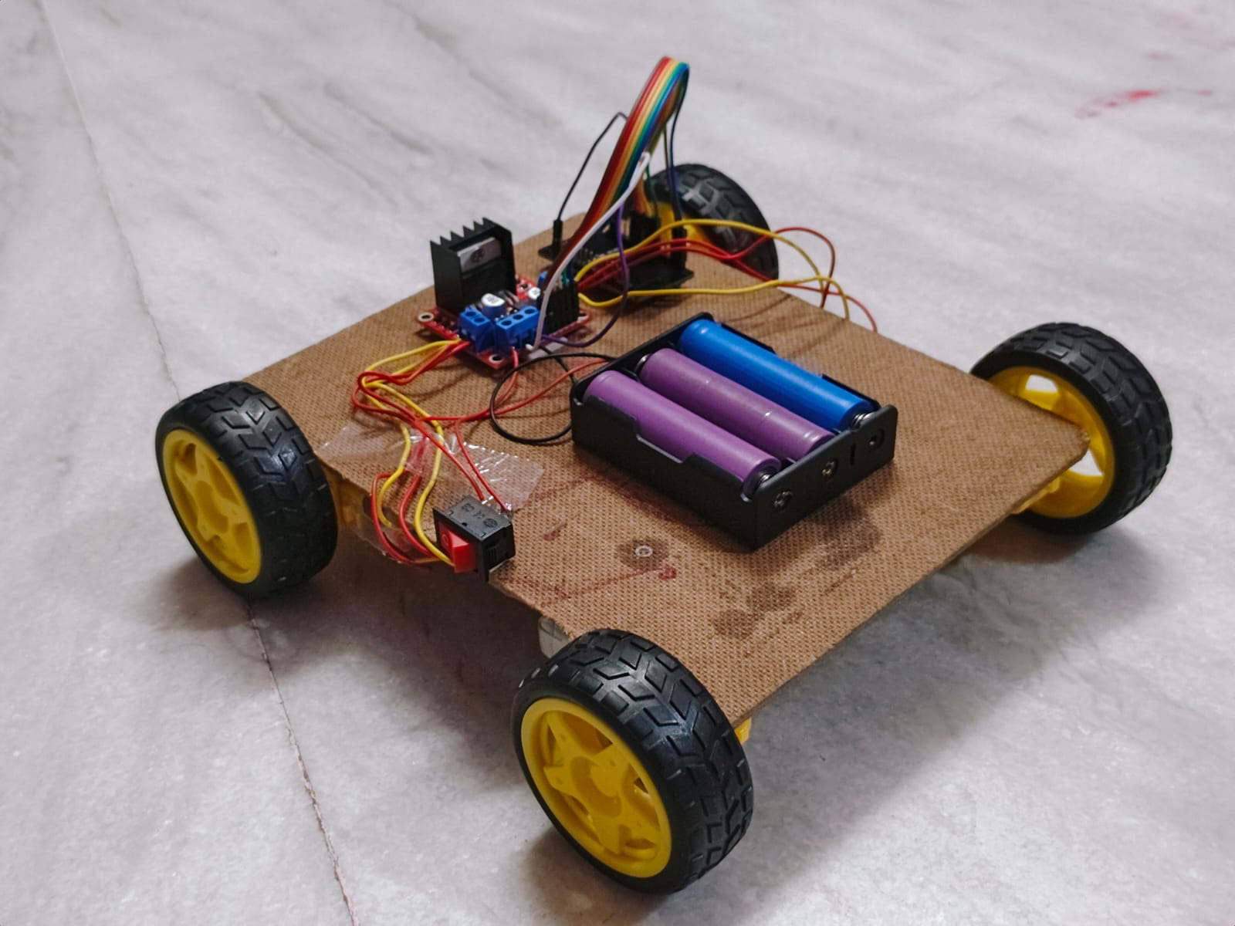

As the shown picture a Bluetooth Control Car is ready.

**CONCLUSION**

The development of a **Bluetooth Controlled Car using ESP32** demonstrates the potential of low-cost, accessible microcontrollers in the field of robotics and automation. As the demand for wireless, intelligent, and remotely controlled systems grows across industries—from consumer electronics to smart mobility and logistics—projects like this serve as foundational platforms for innovation. The ESP32, with its integrated Bluetooth and Wi-Fi capabilities, positions itself as a powerful tool for future Internet of Things (IoT) and robotics applications.

In global trends, the movement toward **autonomous vehicles, smart cities, and wireless control systems** is accelerating. This project aligns with those trends by offering insights into real-time control, embedded system integration, and the seamless communication between devices. While this model uses manual Bluetooth commands, it paves the way for more advanced developments such as AI-based navigation, autonomous control, and cloud-connected robotics. As a result, this project is not only relevant today but also a stepping stone toward the **future of smart robotics and connected technologies**.